**CP Club 365Days Challenge**

**Programming language – C++**

**Problem Statement**

[https://practice.geeksforgeeks.org/problems/minimum-indexed-character-1587115620/1?page=1&difficulty[]=0&category[]=Strings&sortBy=submissions](https://practice.geeksforgeeks.org/problems/minimum-indexed-character-1587115620/1?page=1&difficulty%5b%5d=0&category%5b%5d=Strings&sortBy=submissions)

**Your Code**:

// 0x61Day of 0x365Days challenge

// VEDANT BHARAD

// 17-12-2022

//{ Driver Code Starts

//Initial template for C++

#include <bits/stdc++.h>

using namespace std;

// } Driver Code Ends

//User function template for C++

class Solution

{

    public:

    //Function to find the minimum indexed character.

        int minIndexChar(string str, string patt)

        {

            int minIndex=str.length(),found=0;

            for(int loop=0; loop<patt.length(); loop++)

            {

                int index = str.find(patt[loop]);

                if(index>-1) found=1;

                else found=0;

                if(found==1 && index<=minIndex)

                {

                    minIndex = index;

                }

            }

            if(minIndex==str.length()) return -1;

            return minIndex;

        }

};

//{ Driver Code Starts.

int main()

{

    int t;

    cin>>t;

    while(t--)

    {

        string str;

        string patt;

        cin>>str;

        cin>>patt;

        Solution obj;

        cout<<obj.minIndexChar(str, patt)<<endl;

    }

    return 0;

}

// } Driver Code Ends

**Output (Screen Shot)**:

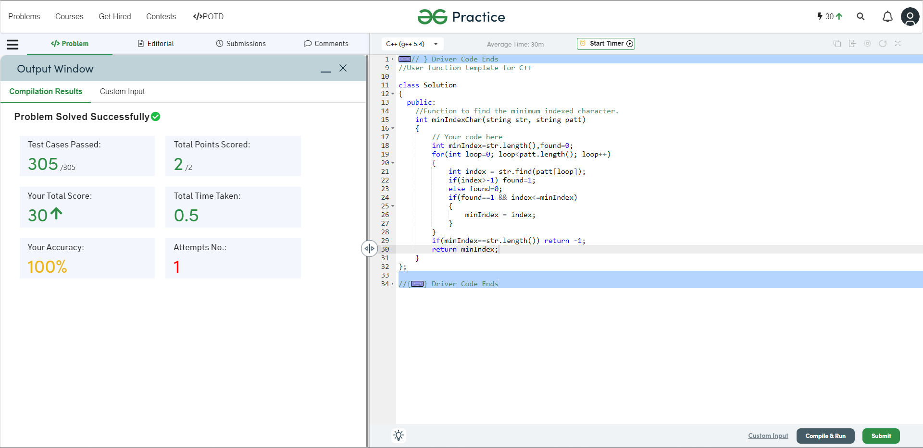

**Understanding about problem:**

**I need to Find the minimum index of the character in str1 that is also present in str2 if not then return -1.**

Note: If you can't understand the problem, feel free to contact us and we'll help you. Please don't copy and paste from anywhere.

ALL THE BEST

Team CP Club